**Batch 471: Day 5- Sequences Practice Problems**

Question No. – 01:

* echo $(( RANDOM%10 ))

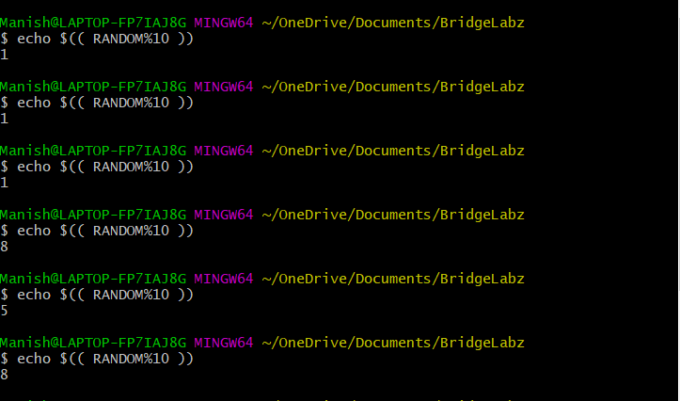

Question No.- 02:

* echo $(( 1+ RANDOM%6 ))

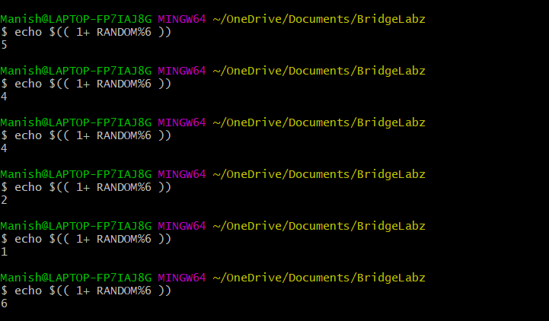

Question No. – 03:

* dice1=$(( RANDOM%6 ));
* dice2=$(( RANDOM%6 ));
* sum=$(( dice1+dice2 ));
* echo $sum

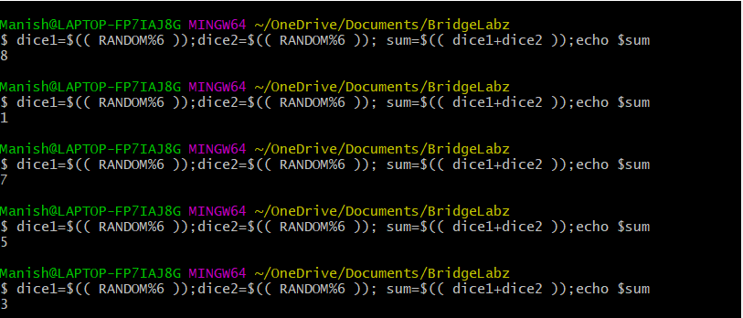

Question No. – 04:

* number1=$(( 10+ RANDOM%10 ));
* number2=$(( 10+ RANDOM%10 ));
* number3=$(( 10+ RANDOM%10 ));
* number4=$(( 10+ RANDOM%10 ));
* number5=$(( 10+ RANDOM%10 ));
* sum=$(( number1+number2+number3+number4+number5 ));
* echo $sum;
* echo $(( sum/5 ))

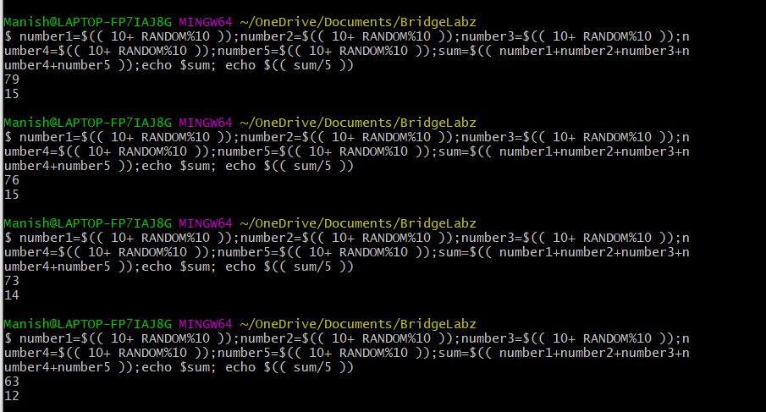

Question No. – 05:

1. echo $(( 42/12 ))
2. awk ‘BEGIN {print (18.288*12.192)}’
3. awk ‘BEGIN {print (18.288*12.192*25)}’

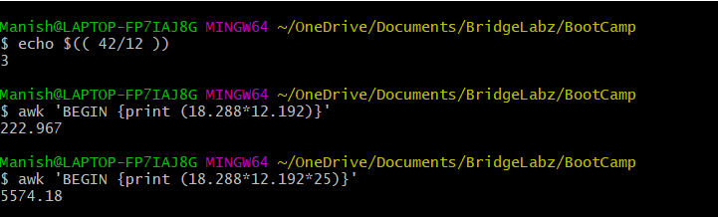

**Day5: Practice Problems with if & else**

Question No. – 02:

read -p “Enter Date : ” date

read -p “Enter Month : ” month

if (( ($month<=6 && $date<=20) && (($month>=3 && $date<=20) && ($date<31)) ))

then

echo $month $date “True”;

else

echo “False”;

fi

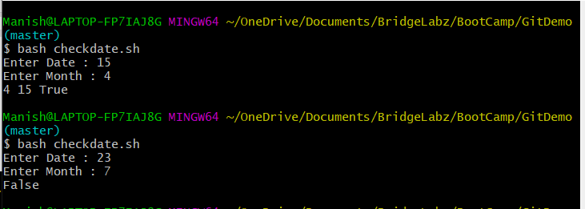

Question No. – 03:

read -p “Enter a year : “ a

x=`expr $a % 4`

y=`expr $a % 100`

z=`expr $a % 400`

if [ $x -eq 0 -a $y -ne 0 -o $z -eq 0 ]

then

echo “$a is a leap year”

else

echo “$a is not a leap year”

fi

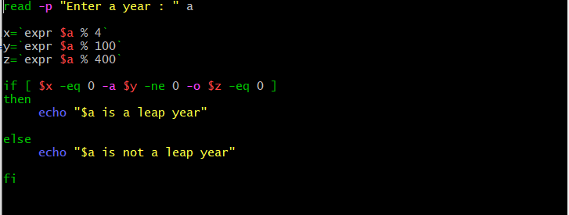

Question No. – 04:

read -p “Enter either 0 or 1 : ” a

if [ $a -eq 0 ]

then

echo “$a is a Head”

elif [ $a -eq 1 ]

echo “$a is a Tail”

else

echo “Please enter either 0 or 1”

fi

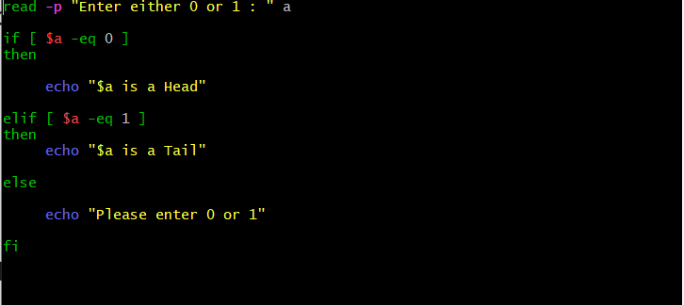

**Day5: Practice Problems with if,elif & else**

Question No. – 01

read -p "Enter a single digit number : " a

if [ $a -eq 0 ]

then

echo "$a means Zero"

elif [ $a -eq 1 ]

then

echo "$a means One"

elif [ $a -eq 2 ]

then

echo "$a means Two"

elif [ $a -eq 3 ]

then

echo "$a means Three"

elif [ $a -eq 4 ]

then

echo "$a means Four"

elif [ $a -eq 5 ]

then

echo "$a means Five"

elif [ $a -eq 6 ]

then

echo "$a means Six"

elif [ $a -eq 7 ]

then

echo "$a means Seven"

elif [ $a -eq 8 ]

then

echo "$a means Eight"

elif [ $a -eq 9 ]

then

echo "$a means Nine"

else

echo "Invalid number"

fi

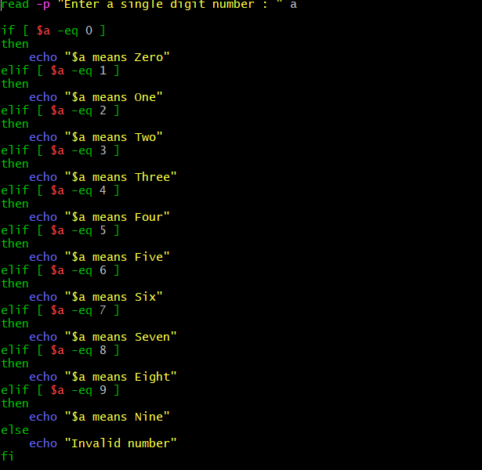

Question No. – 02

read -p "Enter a single digit number : " a

if [ $a -eq 0 ]

then

echo "$a means Sunday"

elif [ $a -eq 1 ]

then

echo "$a means Monday"

elif [ $a -eq 2 ]

then

echo "$a means Tuesday"

elif [ $a -eq 3 ]

then

echo "$a means Wednesday"

elif [ $a -eq 4 ]

then

echo "$a means Thrusday"

elif [ $a -eq 5 ]

then

echo "$a means Friday"

elif [ $a -eq 6 ]

then

echo "$a means Saturday"

else

echo "Invalid number"

fi

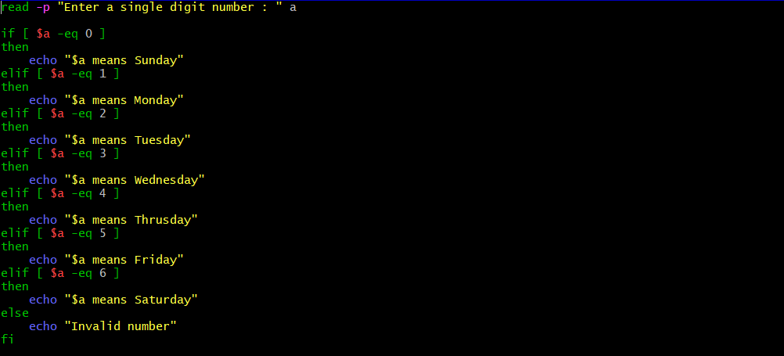

Question No. – 04

read -p "Enter first number : " a

read -p "Enter second number : " b

read -p "Enter third number : " c

x=$((a+b*c))

y=$((c+a/b))

z=$((a%b+c))

n=$((a*b+c))

if [ $x -gt $y -a $x -gt $z -a $x -gt $n ]

then

echo "$x is maximum"

elif [ $y -gt $x -a $y -gt $z -a $y -gt $n ]

then

echo "$y is maximum"

elif [ $z -gt $x -a $z -gt $y -a $z -gt $n ]

then

echo "$z is maximum"

elif [ $n -gt $x -a $n -gt $y -a $n -gt $z ]

then

echo "$n is maximum"

else

echo "Invalid input"

fi

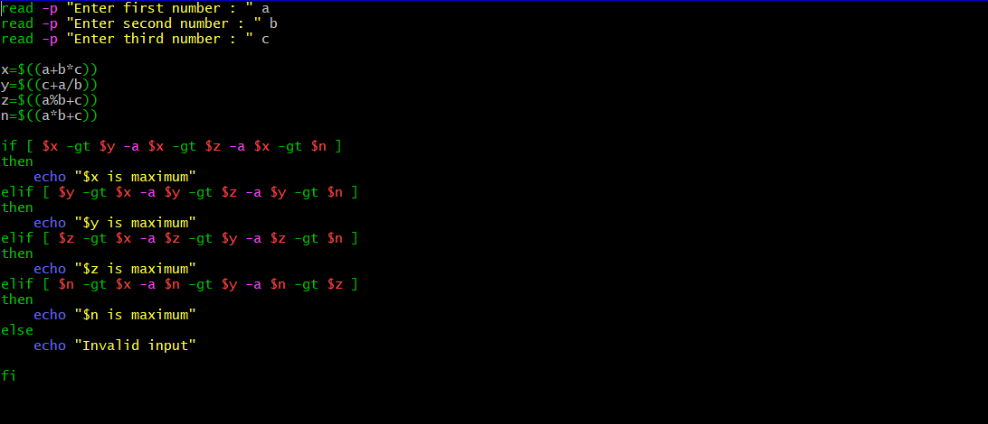

**Day5: Practice Problems with Case**

Question No. – 01

read -p "Enter a single digit number : " a

case $a in 0)

echo "$a means Zero";

;;

1)

echo "$a means One";

;;

2)

echo "$a means Two";

;;

3)

echo "$a means Three";

;;

4)

echo "$a means Four";

;;

5)

echo "$a means Five";

;;

6)

echo "$a means Six";

;;

7)

echo "$a means Seven";

;;

8)

echo "$a means Eight";

;;

9)

echo "$a means Nine";

;;

*)

echo "Invalid number";

esac

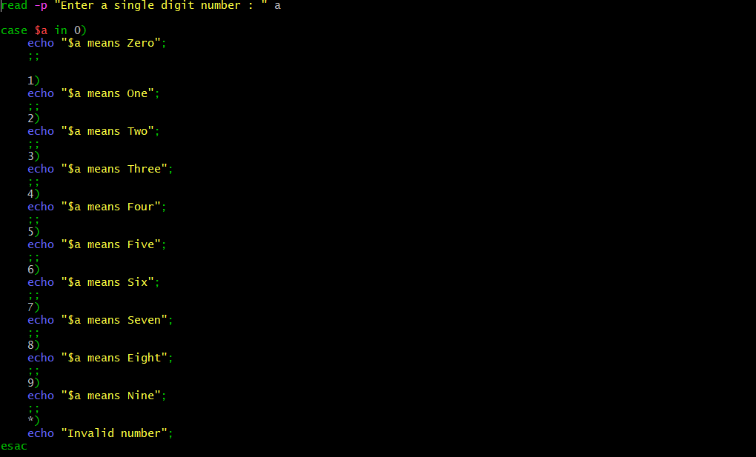

Question NO. – 02:

read -p "Enter a single digit number : " a

case $a in 0)

echo "$a means Sunday";

;;

1)

echo "$a means Monday";

;;

2)

echo "$a means Tuesday";

;;

3)

echo "$a means Wednesday";

;;

4)

echo "$a means Thursday";

;;

5)

echo "$a means Friday";

;;

6)

echo "$a means Saturday";

esac

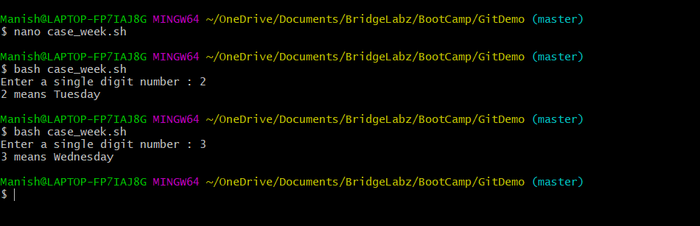

Question No. – 04:

read -p "Enter a number : " a

x=$(($a*12))

y=$(echo $a |awk '{print $a*0.0833}')

z=$(echo $a |awk '{print $a*0.3048}')

n=$(echo $a |awk '{print $a*3.28}')

echo "$x in inch"

echo "$y in feet"

echo "$z in meter"

echo "$n in feet"

